**Title In English (Arial 16, Center, Bold).**

Title in Spanish (Arial 14, center, italic).

Title in French (Arial 14, center, italic).

Author 1, Institution, City, Country; Author 2, Institution, City, Country; Author 3, Institution, City, Country; Author 4, Institution, City, Country

**Abstract**

The abstract in English should be written in Arial 11 font, 1.15 multiple spacing. It should contain a maximum of 150 words. The abstract should be structured in: Introduction (the problem and its justification), Aims, Method (how it was solved), Results and Conclusions (what the findings mean).

**Keywords:** should contain 3 to 5 key words separated by comma (Arial 11). It is suggested to consult the UNESCO Thesaurus to select keywords.

<https://vocabularies.unesco.org/browser/thesaurus/en/index/A>

1. **Introduction**

The introduction should be written in Arial 11, 1.15 multiple spacing, justified. The introduction is the general presentation of the paper, importance, origin, aims, scope and methodology. The introduction should not anticipate conclusions, since they will be presented at the end of the paper.

1. **Heading 1: use this style for level one headings.**

The introduction should

* 1. Heading 2: use this style for level two headings.
     1. Heading 3.
* For bulleted list used point

Table 1. Type your caption here (Arial 10, center).

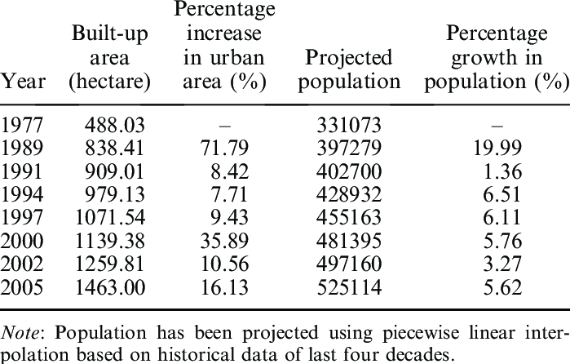

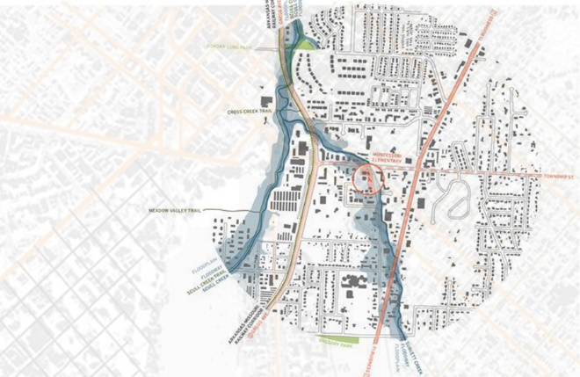

Figure 1. Type your caption here (Arial 10, center).

1. **Conclusions**

Examination, interpretation, and classification of the results.

1. **Acknowledgements**

financial support with the project code and identifying the sponsor.

1. **References** (Arial 10, 1.15 multiple spacing, justified. APA Citations and Format. 7th edition)

Last name, F., Last name, S. M., & Last name, M. (year) title, publisher, pages, electronic source information <http://doi.org/xxxx>

Thirumalini, S., Ravi, R., and Rajesh, M. 2018. “Experimental Investigation on Physical and Mechanical Properties of Lime Mortar: Effect of Organic Addition”. *Journal of Cultural Heritage,* 31, 97–104. <https://doi.org/10.1016/J.CULHER.2017.10.009>